Online Training Module- Learning Journal

for

**“Relationship Building & Communications”**

Dear Early Education Educators,

Use this reflection journal to follow along with the 1-hour online training video. There are questions at the end of each of the 2 sections of the video. To receive ECE-TRIS credit and a certificate for the course: At the end of the 2 video sections, you will be prompted to type these answers into an online form. Once submitted, you will receive a certificate you can print and submit along with other needed 

documentation for ECE-TRIS credit.

Thank you and we hope you enjoy this module.

**Learning Objectives (1 hour):**

• Identify critical attributes of relationship-building

• Explain the role the center and classroom environment play in building relationships with

families

• Identify critical attributes of effective family-center communication

• List ways of using surveys for gathering input and feedback from families

• Explain the importance of two-way family-center communication to the quality of a program

**Recommended reading and references:**

• KY Family and Early Education Partnership Self-Assessment (2022)

• KY Family and Early Education Program Partnership Guide (2022)

• Family Interests & Traditions Form, Family Feedback Survey, Family Communication Tools can

be found in the KY Family and Early Education Partnership Playbook

**Section 1 Notes: Relationship Building**

*Add notes in this section in response to prompts in the video. Consider how your center*

*addresses each of the critical attributes. These notes will help you complete the*

*self-assessment later.*

1. Think about the signage in your center. Is your signage easy to read? Is it welcoming

to families? Does it provide important information and directions?

___________________________________________________________________

___________________________________________________________________

___________________________________________________________________

___________________________________________________________________

1. Do you have dedicated space in your center for information for families? Do you

routinely update information? Is the space easily accessible for families during

open hours? Does your space allow for families and staff to gather?

___________________________________________________________________

___________________________________________________________________

___________________________________________________________________

___________________________________________________________________

1. Does your center collect information from families in a culturally responsive and

respectful way? Do you gather information from families about cultures and

traditions at the time of enrollment?

___________________________________________________________________

___________________________________________________________________

___________________________________________________________________

___________________________________________________________________

1. Does your center view relationships with families as shared responsibility in their

child’s learning?

___________________________________________________________________

___________________________________________________________________

___________________________________________________________________

___________________________________________________________________

1. Does your center gather information from families and embed it into lesson plans?

Does your center use feedback surveys to gather information?

___________________________________________________________________

___________________________________________________________________

___________________________________________________________________

___________________________________________________________________

1. Does your center collect family feedback to help improve program quality?

___________________________________________________________________

___________________________________________________________________

___________________________________________________________________

___________________________________________________________________

1. Does your center have an open-door policy? Does your center cultivate trust with

families?

___________________________________________________________________

___________________________________________________________________

___________________________________________________________________

___________________________________________________________________

1. Does your center use family interest forms to help you learn about their interests

and needs? Does your family collect information on an on-going basis?

___________________________________________________________________

___________________________________________________________________

___________________________________________________________________

___________________________________________________________________

1. Does your center share positive information and strengths with families in addition

to areas of concern?

___________________________________________________________________

___________________________________________________________________

___________________________________________________________________

___________________________________________________________________

1. Does your center offer conference times based on the families’ needs?

___________________________________________________________________

___________________________________________________________________

___________________________________________________________________

___________________________________________________________________

**Section 1 Reflection Journal: Relationship-Building**

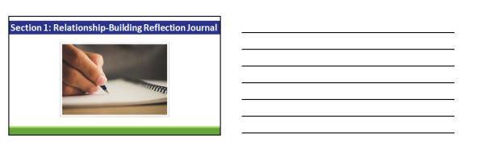

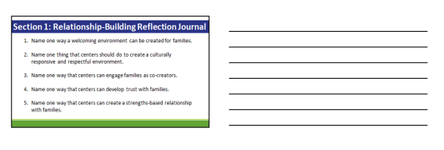

**Section 2 Notes: Communications**

*Add notes in this section in response to prompts in the video. Consider how your center*

*addresses each of the critical attributes. These notes will help you complete the*

*self-assessment later.*

1. Does your center include information about classroom and learning goals at family

events?

___________________________________________________________________

___________________________________________________________________

___________________________________________________________________

___________________________________________________________________

1. Does your center use two-way communication tools? What tools might you use?

___________________________________________________________________

___________________________________________________________________

___________________________________________________________________

___________________________________________________________________

1. Are your modes of communication with families effective for sharing developmentally

appropriate activities with families?

___________________________________________________________________

___________________________________________________________________

___________________________________________________________________

___________________________________________________________________

1. Does your center schedule family conferences only as concerns arise or does your

center offer regularly scheduled (at least twice per year) conferences throughout

the year?

___________________________________________________________________

___________________________________________________________________

___________________________________________________________________

___________________________________________________________________

1. Does your center invite families to volunteer in the classroom?

___________________________________________________________________

___________________________________________________________________

___________________________________________________________________

___________________________________________________________________

1. Does your center use a variety of methods to gather family feedback on program

practices?

___________________________________________________________________

___________________________________________________________________

___________________________________________________________________

___________________________________________________________________

1. Does your center have a family-staff committee?

___________________________________________________________________

___________________________________________________________________

___________________________________________________________________

___________________________________________________________________

1. Does your center provide general information to families with through monthly

newsletters?

___________________________________________________________________

___________________________________________________________________

___________________________________________________________________

___________________________________________________________________

1. Does your center keep families updated on their child’s development and goals?

___________________________________________________________________

___________________________________________________________________

___________________________________________________________________

___________________________________________________________________

1. Does your center have strategies for reaching hard to reach families?

___________________________________________________________________

___________________________________________________________________

___________________________________________________________________

___________________________________________________________________

**Section 2 Reflection Journal: Communications**

