Online Training Module- Learning Journal

for

**“Family Engagement: Beyond the Newsletter: Introduction to Family and School Partnership for KY Early Care and Education Programs”**

Dear Early Education Educators,

Use this reflection journal to follow along with the 1 hour online training video. There are questions at the end of each of the 4 sections which are approximately 20 minutes each. To receive ECE-TRIS credit and a certificate for the course: At the end of the 4 video sections (1 hour total) you will be prompted to type these answers into an online form. Once submitted, you will receive a certificate you can print and submit along with other needed documentation for ECE-TRIS credit.

Thank you and we hope you enjoy this introductory module.



**Learning Objectives (1 hour):**

1. Explain the difference between family “involvement” and “Family 

Partnership”

2. List roles families can play and how you can support each role

3. Learn and apply the Dual Capacity Building Framework to early

education programming

4. Name 2 everyday strategies you can start now

**Recommended reading and references:**

• “Beyond the Bake Sale”, Henderson, Mapp, Johnson, Davies (2007)

• “Powerful Partnerships”, Mapp, Carver, Lander (2017)

• dualcapacity.org

• “Ky Family and Early Education Program Partnership Guide” (2022)

| **Section 1: Explain the difference between family “involvement” and “Family Partnership”** | |
| --- | --- |
| SLIDE | NOTES: |
|  | ___________________________________ ___________________________________ ___________________________________ ___________________________________ ___________________________________ ___________________________________ |
| WHAT IF...  **What stood out to you in this video about the possibilities of how REAL**  **family partnership could change the education experience for kids?** | ___________________________________ ___________________________________ ___________________________________ ___________________________________ ___________________________________ ___________________________________ |
| Family engagement is a shared responsibility in which schools  and other community agencies and organizations are  committed to reaching out to engage families in meaningful  ways and in which families are committed to actively supporting  their children's learning and development.  *- NAFSCE, https://nafsce.org/page/definition*  Family engagement is a full, equal, and equitable partnership  among families, educators and community partners to promote  children’s learning and development from birth through college  and career.  *- CT Statewide Family Engagement Center, https://www.ct*  *fsp.org/about-us/*  Transformative family engagement is a shared effort of families,  schools and community leaders to advance programs, practices  and policies that empower every parent to make their child’s  potential a reality.  *- National PTA https://www.pta.org/center-for-family*  *engagement* | ___________________________________ ___________________________________ ___________________________________ ___________________________________ ___________________________________ ___________________________________ |
| **KY Family Engagement:**  A productive, equitable and inclusive partnership among  families, educators and the community to promote  children’s learning and development from birth through  college and career, and across home, school, and  community settings.  Family, school and community partnerships are about  building active, reciprocal relationships in which schools,  families and community agencies and organizations engage  in meaningful and culturally appropriate collaboration to  improve student outcomes.  *We use the following 5 terms interchangeably to reflect the above*  *definition.*  ● Family and early education partnership  ● Family engagement  ● Family, early education and community partnership  ● Family, early education and community engagement  ● Parent Involvement (used most frequently in Kentucky regulations)  KY Collaborative for Families and Schools, 2021 | ___________________________________ ___________________________________ ___________________________________ ___________________________________ ___________________________________ ___________________________________ |

| We can do this better  **How we used to think… What we know NOW**  “Involvement”- Doing TO families “Partnership”- Doing WITH families  Give information Build family skills  Large group gatherings More one-on-one conversations; small group convenings  Share when there are issues or problems Celebrate milestones and progress together  “Come if we call” Must share “Funds of Knowledge”  Assume families know how to support their child’s education Early education providers set the tone and teach families how to  be partners in their kids education and they have the RIGHT to be  partners with the school  Family engagement is a program Family engagement is often the missing piece in our apprach to  student achievement | ___________________________________ ___________________________________ ___________________________________ ___________________________________ ___________________________________ ___________________________________ |
| --- | --- |
| ***DID YOU KNOW?***  “Students with involved parents, no matter what  their income or background, were more likely to:  • Earn higher grades and test scores and enroll  in higher-level programs.  • Be promoted, pass their classes, and earn  credits.  • Attend school regularly.  • Have better social skills, show improved  behavior, and adapt well to school.  • Graduate and go on to postsecondary  education.”  *A New Wave of Evidence, Henderson and Mapp, 2002*  References:https://sedl.org/connections/resources/evidence.pdf | ___________________________________ ___________________________________ ___________________________________ ___________________________________ ___________________________________ ___________________________________ |
| *End of Section 1 Question:*  **1. Explain the difference between family “involvement” and “Family Partnership.”** You might also use this space to discuss “ah-has” are you already having about how you thought about family engagement before and how you are starting to shift your attitudes and beliefs? If nothing shifted, what were you reminded of regarding effective family engagement in early education programs? | |

| **Section 2: List roles families can play and how you can support each role** |
| --- |

***Full Article here:*** *https://prichardcommittee.org/wp-content/uploads/2021/06/its-time-to-redefine family-and-community-engagement.pdf*

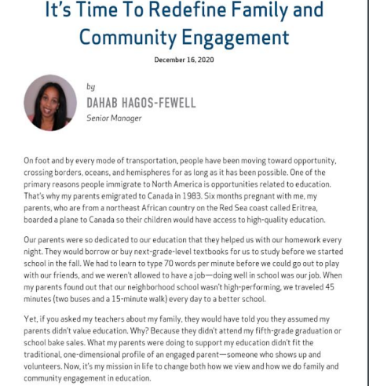

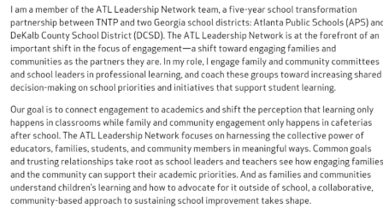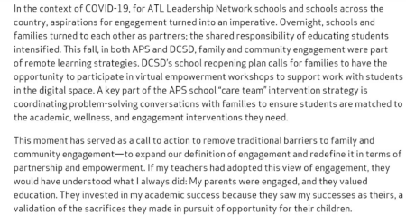

**For self-reflection: Can you relate to Dahab’s story from your own childhood? Why does this story matter in an introductory to family engagement training?**

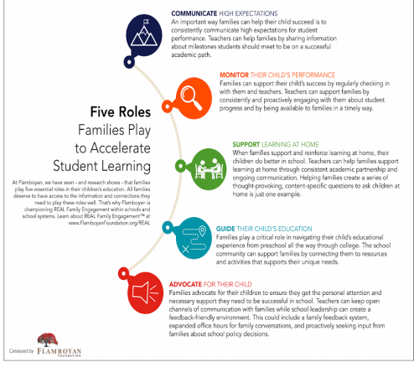**Image retrieved from: https://s28742.pcdn.co/wp-content/uploads/2020/01/Five-Roles-Families Play_Flamboyan-Foundation.pdf**

**For self-reflection: Which role did your parent play most often? Which role do you identify with either as a parent or personality type?**

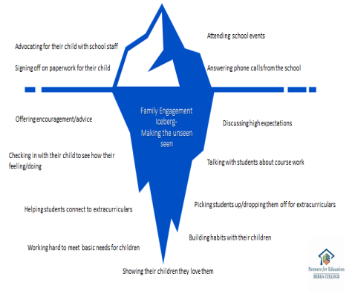

| **So, what does this mean?**  ***When we think about improving family engagement we***  ***have to go beyond how we improve our***  ***family events and newsletters, instead we need to put our***  ***time and energy into strategies that help staff get to know***  ***families so we can build trusting relationships between***  ***families and teachers.***  ~KY Collaborative for Families and Schools, 2021  **So, how do we do it?**  **“We actually sit down and talk to families”- *Carnegie and Harvard Presentation, June 2021*** |
| --- |

___________________________________ ___________________________________ ___________________________________ ___________________________________ ___________________________________ ___________________________________ ___________________________________

|  | ___________________________________ ___________________________________ ___________________________________ ___________________________________ ___________________________________ ___________________________________ ___________________________________ |
| --- | --- |
| **End of Section 2 Questions:**  **1. List one way you better support families with skills they can use at home? 2. How can you begin learning how families want to be involved i.e. what role they want to play? 3. How can you begin the exchange of family and provider “Funds of knowledge?** | |

| **Section 3: Dual Capacity Building Framework** |
| --- |
| *https://dpi.wi.gov/sites/default/files/imce/sspw/TSSFamily_FourVersionsofFamilyPartnerships.pdf* |

gr

o

.

y

t

ic

a

p

a

c

la

u

d

| **Core Beliefs**  1. All families have dreams for their children and want the best for them.  2. All families have the capacity to support their children’s learning.  3. Families and school staff are equal partners.  4. The responsibility for cultivating and sustaining partnerships among school, home, and community rests primarily with the school staff, especially school leaders.  **Circle the beliefs that resonates with you most and star the belief you are**  **challenged by most.**  26 |
| --- |

| 27 |
| --- |

| **Policy and Program Goals**  Build and enhance the capacity of educators and families in the “4 Cs” – Capabilities (skills and knowledge)  – Connections (networks)  – Cognition (shifts in beliefs and values)  – Confidence (self-efficacy and advocacy)  *Make a list of current FE Programs*  *If they have 4Cs*  28 |
| --- |

| ___________________________________ ___________________________________ ___________________________________ ___________________________________ ___________________________________ ___________________________________ ___________________________________ |
| --- |
| ___________________________________ ___________________________________ ___________________________________ ___________________________________ ___________________________________ ___________________________________ ___________________________________ |
| ___________________________________ ___________________________________ ___________________________________ ___________________________________ ___________________________________ ___________________________________ ___________________________________ |

| **End of Section 3 Questions:**  Build and enhance the capacity of educators and families in the “4 Cs”  • Capabilities (skills and knowledge)  • Connections (networks)  • Cognition (shifts in beliefs and values)  • Confidence (self-efficacy and advocacy)  **1. Rewrite a family engagement touchpoint so all 4C’s are accomplished:**  **2. Bonus points!**  **A. Can you also give yourself a check mark for all the Essential Process Conditions? B. How could family members help you CO-DESIGN this project/event/strategy each year?** |
| --- |

| **Section 4: Everyday Strategies you can do now** |
| --- |

**Quick and Easy Ideas:**

**Everyday Family Engagement Strategies for Early Education Programs**

1. Enrollment Sets the Tone! Give families a one pager that sets the expectation that families are key partners in the success of their child. Lay out what the families can expect from the program such as Monthly newsletter from the director, Frequent communication from their child's staff and describe what is expected of the family stating “ You can play a role in your child’s education in any of the

following ways”... and list multiple roles your Center invites families to participate and have them check-mark which ways interest them for example: Will attend quarterly family nights where they can meet other families and/or I will learn new ways of working with my child at home to support learning at school

2. Greet every family by name instead of “Jack’s mom”

3. Learn the home languages of all your families and translate 

materials

4. Create signage that sets the tone that families are essential to

child’s success. Ex. “Together we are Better!”, “Families and Teachers

Funds of Knowledge- Ask us what this means”, “You are your child’s

1st and most important teacher”, “Roles families play in our Center.” Use real pictures of current families when you can to expand on the statement.

5. During a staff meeting have staff reflect to the 4 core beliefs and share which families each finds most difficult to partner with and why. You will notice this is different for each staff person and staff can support one another with different types of families.

6. Intentionally make note of families that don’t typically respond or participate and choose a staff person to investigate how that family likes to be communicated with and other barriers that may exist.

7. Invite community partners to host “Parent Workshops” where 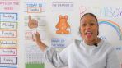

they can promote their services and you can help families

connect. Offer childcare and translation when possible.

8. Utilize Zoom and online platforms for communications

YouTube videos explaining new classroom concept and lessons 

that month. *Look into different online translation features*

- “Zoom Story time”

- “YouTube- About our Classroom Calendar”

- “YouTube-Strength Spotting in 2 and 3-year-olds”

9. Every classroom posts its weekly schedule on Monday outside the door, by text and by email. Always include a “Here’s what you can do at home” section. Even simple questions like, “Did you start a new letter this week?” 

10. Every staff person wears a name tag with their first name, 

posts a short bio outside the classroom and on the school website.

11. Host “Family Conferences” at least 3 times a year this can be in person, on the phone or online video.

12. Make sure that the tone of all family communications is respectful and promote partnership. “If I was a parent, would this feel good to receive?”

13. Highlight and celebrate families and staff who are 

demonstrating effective partnerships. “Power Partnership Spotlight”

14. Family partnership has a prominent place on the program's

website

15. The space where staff and families gather is welcoming and has

adult sized chairs :) Make it look like a living room.

16. The program surveys families for their input on program improvements, desired topics for quarterly learning programs, preferred events, guest speakers from the community, etc. Offer multiple ways families can give their input and translate.

17. Classroom staff send home at least monthly activities that families can do with their children.

18. Put up a “Give and Get” Board where families can offer 

items or services they can give and request things they

need. For example “I have toddler boys clothes” “Call me if

you need a ride to Kindergarten orientation night. I live in

Hallow Woods” and on get things like “Anyone have coats

size 3? Text:____”. Ask a parent to oversee this board each

year so it’s for “parents by parents”

19. Ask families to write a “Hopes and Dreams” letters request every 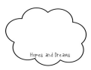

year. What do they hope and dream for their child this coming year?

Have teachers read these letters to learn more about families.

20. Set families up for success with a strong transition to Kindergarten

plan with all local schools. Visits, letters, and introduction phone calls.

Send families with a list of their child’s strengths, learning styles,

important things to know unique personality, challenges, and how the family is and wants to be involved as a Partner!

This idea list was created for Ky Early Education Centers by Ky Collaborative for Families and Schools. Find more resources here: https://prichardcommittee.org/familyengagement/ (3.15.22)

| **End of Section 4 Question:**  **1. Name 2 of the Everyday Opportunity Strategies you will use now to begin improving your family partnership.** |
| --- |

Congratulations! You have completed **“Family Engagement: Beyond the Newsletter: Introduction to Family and School Partnership for KY Early Care and Education Programs”**. Return to the main webpage to submit your End of Section Questions to receive a Certificate of Completion for this module. You can continue your learning journey with individual modules on the KY Family and Early Education Program Self-Assessment which can lead to a Family Friendly Certificate for your program!

More resource and information: https://prichardcommittee.org/familyengagement/